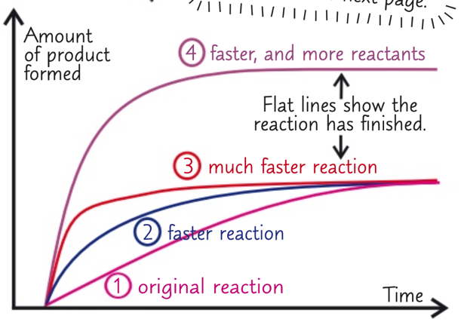***Chemistry notes:***

***Topic 6 – The rate and Extent of Chemical Change:***

**Rates of reaction:**

* The rate of a chemical reaction is how fast the reactants are changed into products
  + Mean rate of reaction (mol/s or g/s or cm3/s):
    - Quantity of reactant used (mol or g or cm3) / Time taken
    - Quantity of product formed (mol or g or cm3) / Time taken
* The steeper the line on a graph
  + The faster the rate of reaction
* Over time the line becomes less steep as the reactants are used up
* The quickest reactions have the steepest lines and become flat in the least time
* Rate of reaction depends on:
  + Collision frequency (how often they collide)
    - The more collisions there are the faster the reaction is
  + The energy transferred during a collision
    - The particles have to collide with enough energy for a collision to be successful

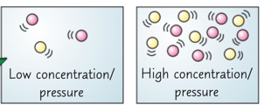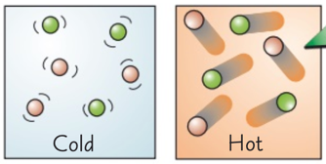**Factors affecting rate of reaction:**

The rate of a chemical reaction depends on 4 things:

* Temperature
  + When the temperature is increased, the particles all move faster
    - 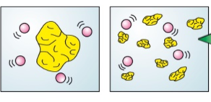This means that they will collide more frequently
  + Also, the faster they move the more energy they have, so more of the collisions have enough energy to make the reaction occur
* Concentration of a solution / Pressure of gas
  + If the concentration is increased it means that there are more particles in a volume of solvent
  + If there is a higher pressure of gas, it means there are the same number of particles in a smaller space
    - This makes collisions between the reactant particles more frequent
* A screenshot of a cell phone

  Description automatically generatedSurface area
  + If one of the reactants is a solid, then breaking it up into smaller pieces will increase its surface area to volume ratio
  + This means that for the same volume of the solid
    - The particles around it have more area to work on, meaning there will be more frequent collisions
* Presence of a catalyst
  + A catalyst is a substance that speeds up a reaction without being used up in the reaction itself
    - This means that it’s not part of the overall equation
  + They work by decreasing the activation energy required for the reaction to occur

**Rate Experiments:**

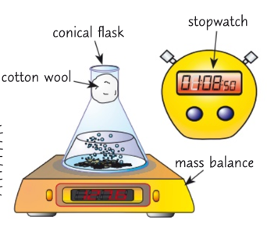

Experiment 1 – Magnesium and HCl react to produce H2 gas:

* + - 1. Start by adding a set volume of dilute hydrochloric acid to a conical flask and carefully place it on a mass balance
      2. Now add some magnesium ribbon to the acid and quickly plug the flask
      3. Start the stopwatch and record the mass on the balance, take readings at regular intervals
      4. Plot the results in a table and work out the mass lost for each reading
         1. Time on the x axis and mass lost on the y axis
      5. Repeat with more concentrated acid solutions
      6. The graphs should show that a higher concentration of aid gives a faster rate of reaction

Experiment 2 – Sodium Thiosulfate and HCl produce a cloudy precipitate

* 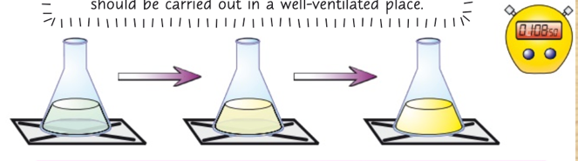These two chemicals are both clear solutions, they react to form a yellow precipitate of sulfur
  + - 1. Start by adding a set volume of dilute sodium thiosulfate to a conical flask
      2. Place the flask on a piece of paper with a black cross drawn on it
      3. Add some dilute HCl to the flask and start the stopwatch
      4. See how long it takes for the cross to disappear due to the cloudy sulfur
      5. Higher the concentration, the faster the reaction

**Finding reaction rates from graphs:**

* MEAN REACTION RATE FROM A GRAPH
* A rate of reaction graph shows the amount of product formed or amount of reactant used up on the y axis and the time on the x axis
* A close up of a map

  Description automatically generatedSo, to find the mean rate for the whole reaction
  + You do overall change in y value / total time taken
  + You can also use it to find the mean rate of reaction between any two points
* DRAWING A TANGENT TO FIND THE RATE OF REACTION
* To work out the rate of reaction at a certain point in time, you need to find the gradient.
  + To do this, first draw a tangent on the point where you want to find the rate
* Draw line the line across the whole graph
* Then find the gradient of this line
  + Do this using the equation change in y / change in x

**Reversible Reactions:**

* A Reversible reaction
  + When a reaction has a forward and backward pathway
* 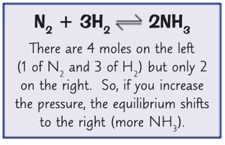A close up of a sign

  Description automatically generatedEquilibrium
  + When the forward and backward reactions occur at the same rate
  + And the number of reactants and products present are unchanging
  + It is only reached in a closed system
    - Which is where neither the reactants nor products can escape
* Positions of equilibrium
  + Equilibrium can lie on either the right or left
  + Equilibrium can shift in order to oppose any change in the system
  + The three factors that can change the position of equilibrium are
    - Temperature
      * If temperature increases, equilibrium shifts to favour the endothermic reaction
      * 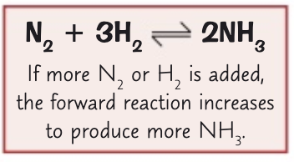If temperature decreases, equilibrium shifts to favour the exothermic reaction
    - Pressure and concentration
      * If you increase pressure or concentration, equilibrium will shift to the reaction that has the least number of moles
      * If you decrease pressure or concentration, equilibrium will shift to the reaction that has the greatest number of moles
* In reversible reactions, if the reaction is endothermic in one direction it will be exothermic in the other
* 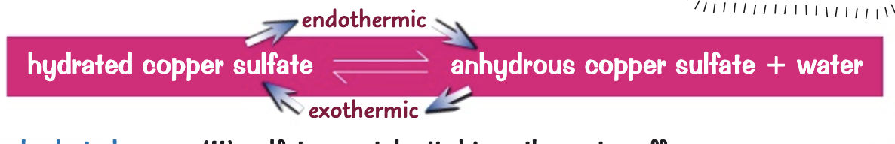An example is the thermal decomposition of hydrated copper Sulfate:
* If you heat blue hydrated copper (II) Sulfate crystals, it drives the water off and leaves white anhydrous copper (II) Sulfate power. This is endothermic
* If you then add a couple of drops of water to the white powder you get the blue crystals back again, this is endothermic
* ***Le Chateliers Principle***
  + The idea that if you change the conditions of a reversible reaction at equilibrium, the system will try to counteract that change
    - This can be used to predict the effect of any changes that you make to a reaction system